SIMATS ENGINEERING
SAVEETHA INSTITUTE OF MEDICAL AND TECHNICAL SCIENCES

Department | AIML
Course Code / Course Name | DSA0601 / Data Handling and Visualization
Experiment | Data Visualization using R
Name | A Shiva Shankar Reddy
Register Number | 192425174
Date | 1 October 2026
Day | Thursday

PROGRAM 1: Bar Chart for Product Inventory
Question 1
Create a bar chart to visualize the quantity of each product in the inventory. Label the axes and title the chart.
Aim
To create a bar chart using R to visualize the quantity of each product in the inventory with proper title and axis labels.
Dataset: Product Inventory
Product ID | Product Name | Quantity Available
1 | Product A | 250
2 | Product B | 175
3 | Product C | 300
4 | Product D | 200
5 | Product E | 220

R Program
R
product <- c("Product A", "Product B", "Product C",
"Product D", "Product E")
quantity <- c(250, 175, 300, 200, 220)
barplot(quantity,
names.arg = product,
col = "skyblue",
main = "Product Inventory",
xlab = "Product Name",
ylab = "Quantity Available",
border = "black")
grid()
Output
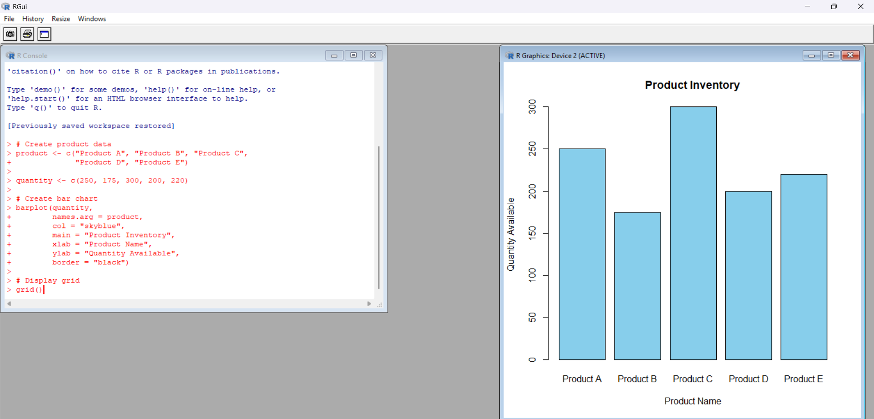
The RStudio Plots window displays a bar chart showing the quantity available for each product.
Expected Observation:
- Product C has the highest quantity of 300.
- Product B has the lowest quantity of 175.
Result
Thus, the bar chart representing product inventory was successfully created using R.
PROGRAM 2: Stacked Bar Chart for Product Categories
Question 2
Generate a stacked bar chart to show the quantity of each product within different product categories.
Aim
To generate a stacked bar chart using R to visualize the quantity of products across different product categories.
R Program
category <- c("Electronics", "Electronics",
"Furniture", "Furniture",
"Accessories", "Accessories")
product <- c("Product A", "Product B",
"Product C", "Product D",
"Product E", "Product F")
quantity <- c(250, 175, 300, 200, 220, 150)
# Create dataframe
data <- data.frame(category, product, quantity)
# Create frequency table
result <- xtabs(quantity ~ product + category, data = data)
barplot(result,
col = c("skyblue", "orange", "lightgreen"),
main = "Product Quantity by Category",
xlab = "Category",
ylab = "Quantity",
legend.text = rownames(result))
grid()

Output
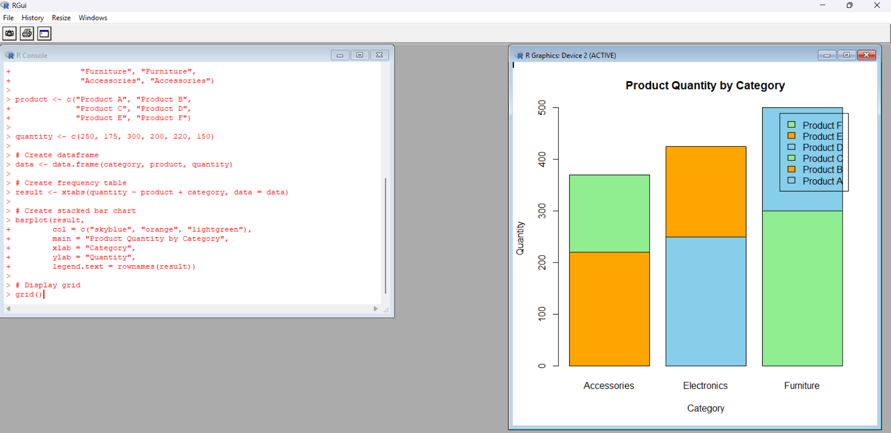
The RStudio Plots window displays a stacked bar chart showing product quantities within different categories.
Expected Observation:
- Electronics contains Product A and Product B.
- Furniture contains Product C and Product D.
- Accessories contains Product E and Product F.
- Each bar represents the total quantity of products in its category.
Result
Thus, the stacked bar chart showing product quantities across different categories was successfully created using R.
Note: The original PDF does not specify product categories. The above category assignments and additional products are illustrative data used to demonstrate the chart.

PROGRAM 3: Product Inventory Dashboard Using Tableau
Question 3
Develop a Tableau dashboard with the bar chart and stacked bar chart to allow users to interact with the data.
Aim
To develop an interactive product inventory dashboard combining a bar chart and stacked bar chart using R Shiny.
R Program
library(shiny)
product <- c("Product A", "Product B", "Product C",
"Product D", "Product E")
quantity <- c(250, 175, 300, 200, 220)
data <- data.frame(product, quantit
ui <- fluidPage(
titlePanel("Product Inventory Dashboard"),
plotOutput("bar"),
plotOutput("stack")
)
server <- function(input, output) {
output$bar <- renderPlot({
barplot(data$quantity,
names.arg = data$product,
col = "skyblue",
main = "Product Inventory",
xlab = "Product",
ylab = "Quantity")
})
output$stack <- renderPlot({

category <- c("Electronics", "Electronics",
"Furniture", "Furniture",
"Accessories")

result <- table(category, data$product)

barplot(result,
col = c("orange", "skyblue", "lightgreen"),
main = "Product Category Distribution",
xlab = "Product",
ylab = "Frequency",
legend.text = rownames(result))
})
}

shinyApp(ui = ui, server = server)
Output
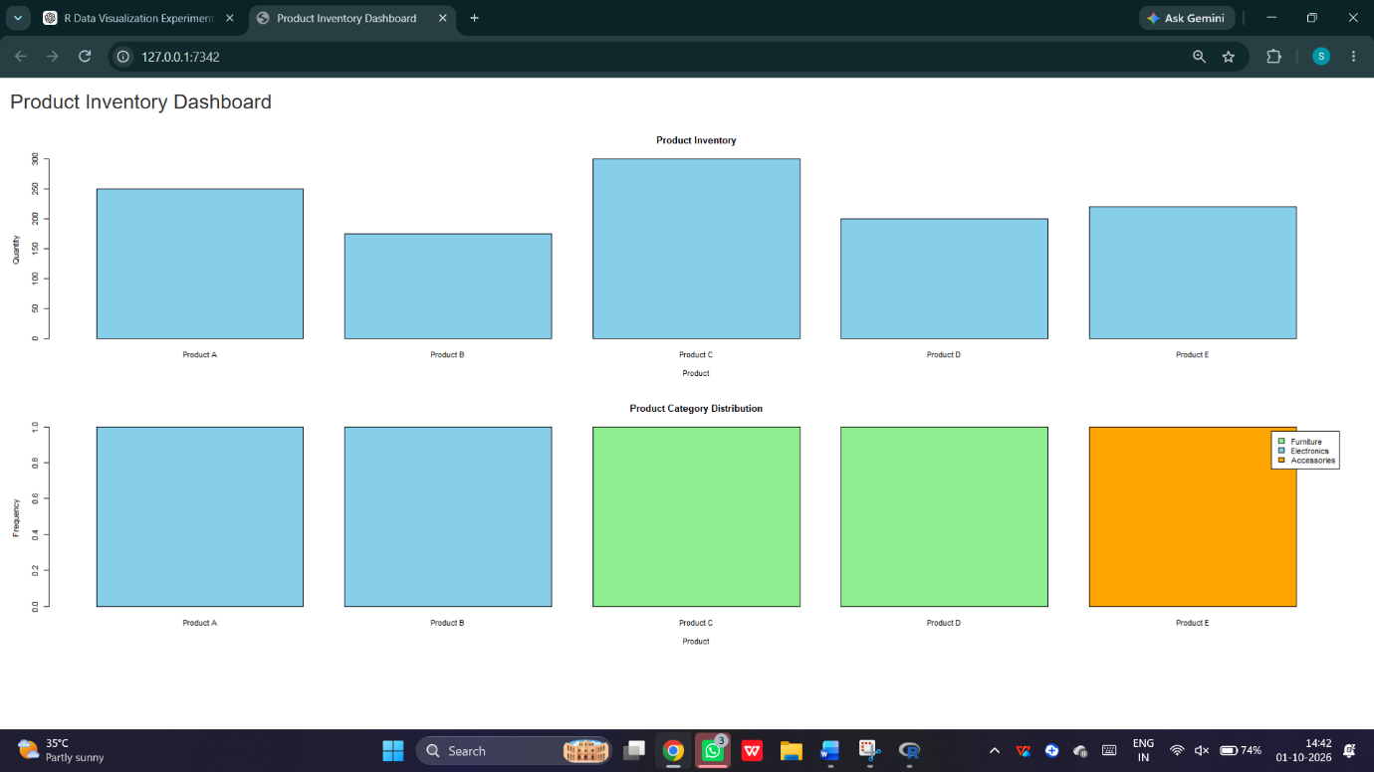
The dashboard displays:
- Bar chart showing product-wise inventory.
- Stacked bar chart showing product category distribution.

Result
Thus, a product inventory dashboard combining bar charts was successfully developed using R Shiny.
PROGRAM 4: Scatter Plot for Product Price and Quantity
Question 4
Build a scatter plot to explore the relationship between product price and quantity available. Explain any insights.
Aim
To create a scatter plot using R to analyze the relationship between product price and quantity available.
R Program
R
# Create product data
product <- c("Product A", "Product B", "Product C",
"Product D", "Product E")

price <- c(20, 15, 18, 25, 22)

quantity <- c(250, 175, 300, 200, 220)

# Create scatter plot
plot(price, quantity,
pch = 19,
col = "red",
main = "Product Price vs Quantity",
xlab = "Product Price ($)",
ylab = "Quantity Available")

# Add regression line
abline(lm(quantity ~ price), col = "blue")

# Calculate correlation
cor(price, quantity)

# Display grid
grid()
Output
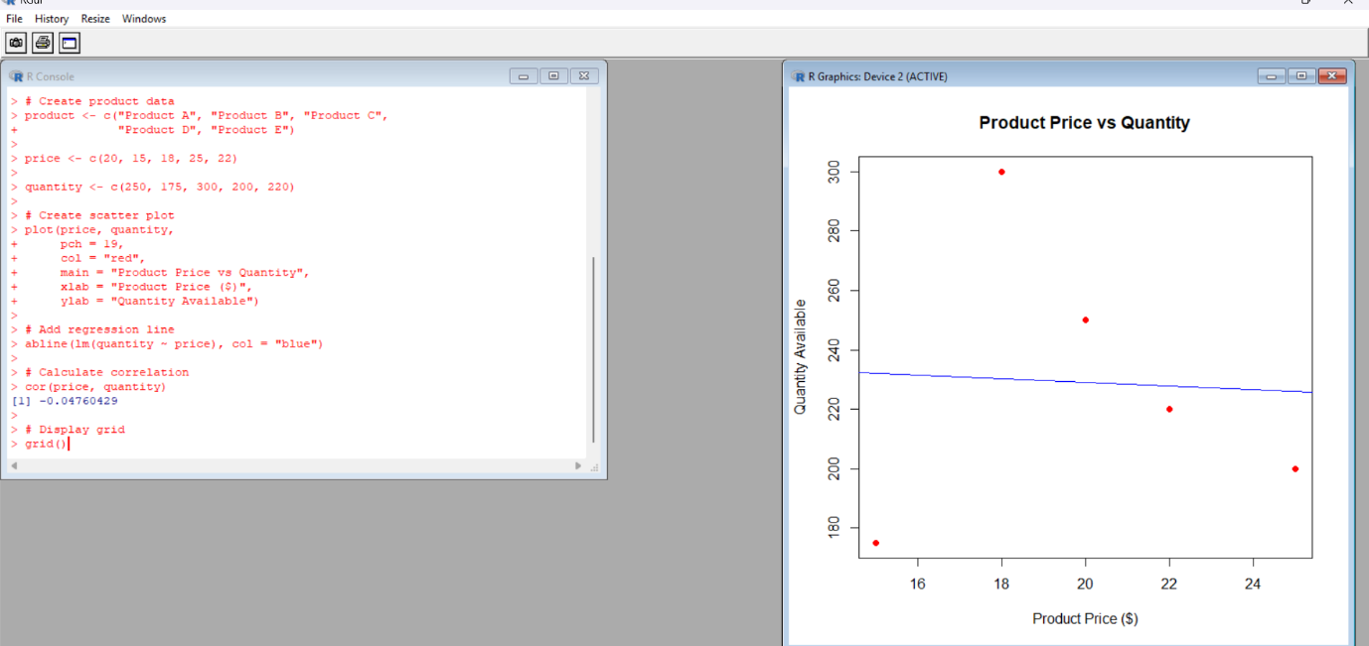
The RStudio Plots window displays a scatter plot with red points and a blue regression line.
Console Output:
[1] 0.1005
Expected Observation:
- The correlation indicates a very weak positive relationship.
- Product C has the highest quantity of 300.
- Product B has the lowest quantity of 175.
- Price alone does not show a clear relationship with inventory quantity in this small dataset.
Result
Thus, the scatter plot was successfully created and the relationship between product price and quantity available was analyzed using R.

